**Assignment 4**

* Add validations for the form DONE
* Use regex to validate phone number, email and zip code. **DONE**
* Validation should show a red color text along with each field and disappear on correcting particular field **DONE**
* Create a single select list box which has 5 elements **DONE**
* Write an onChange event for the created list which adds checkbox that changes dynamically for each selection **DONE**

**Example**:

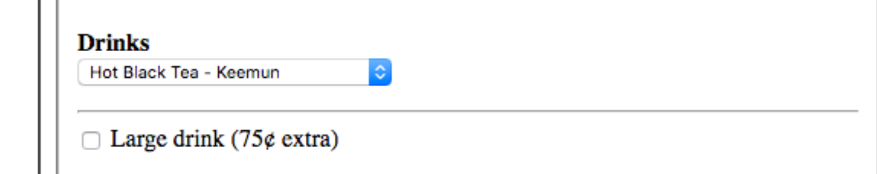

* If the checkbox is enabled, add a text field and make it mandatory and on disabling checkbox, text field should disappear **DONE**
* On submit, create a html table which takes all the data from the previously submitted form and display results **DONE**
* On submit, make sure all the form fields gets cleared out **DONE**
* Add validation for email address (restrict the domain to @northeastern.edu) **DONE**
* Street address 2 is not a mandatory field, on submit click if the field is blank then its value in the table should be blank as well **DONE**

Queries:

1. There’s a novalidate tag added to the form,